Parameters

Frequency: 60MHz – 8.06GHz, 401 equally spaced points
Scan region:
x = -90cm – 90cm, 2cm increment (91 points)
y = -90cm – 90cm, 2cm increment (91 points)

Air Experiment Setup

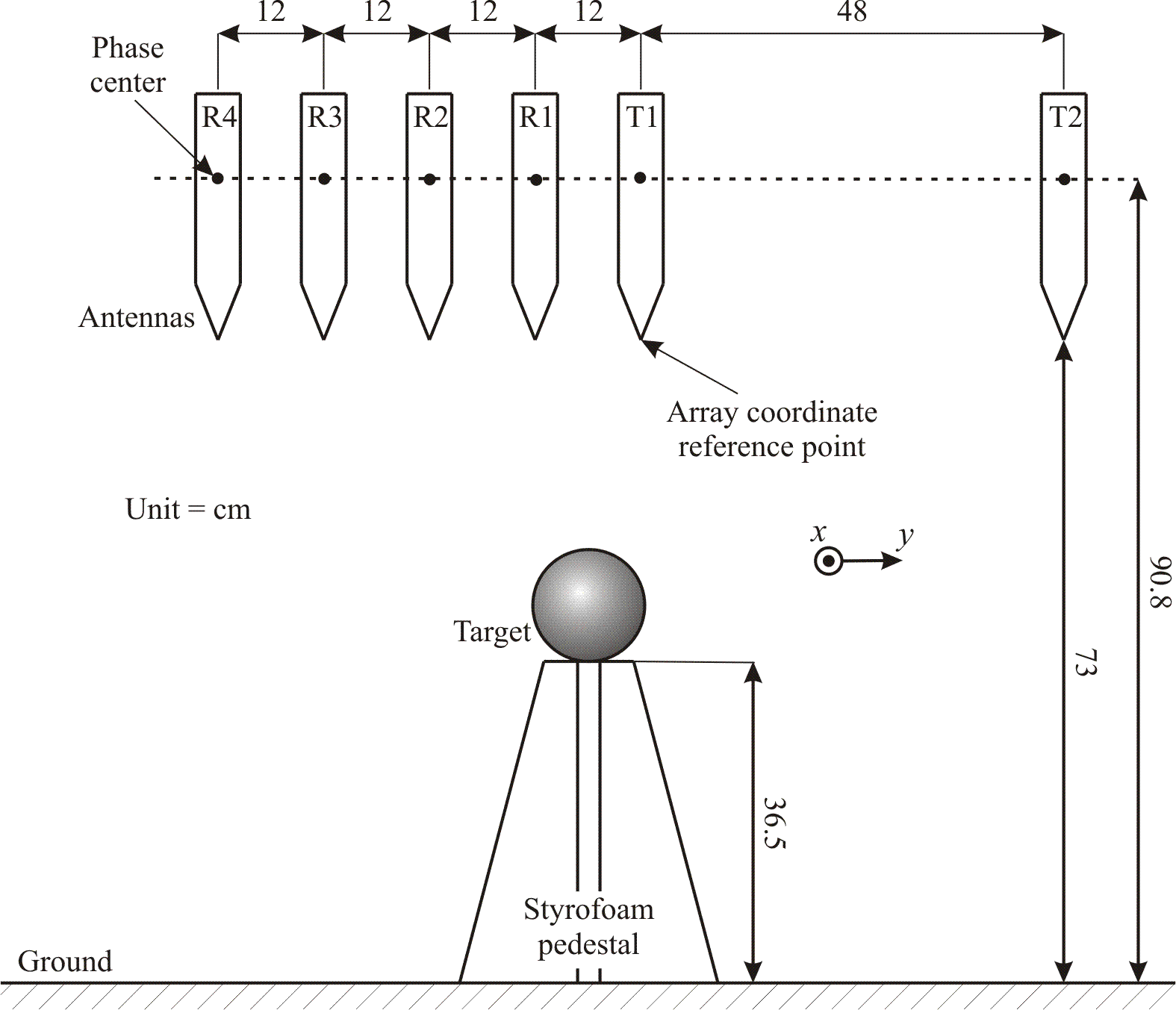

Air Targets
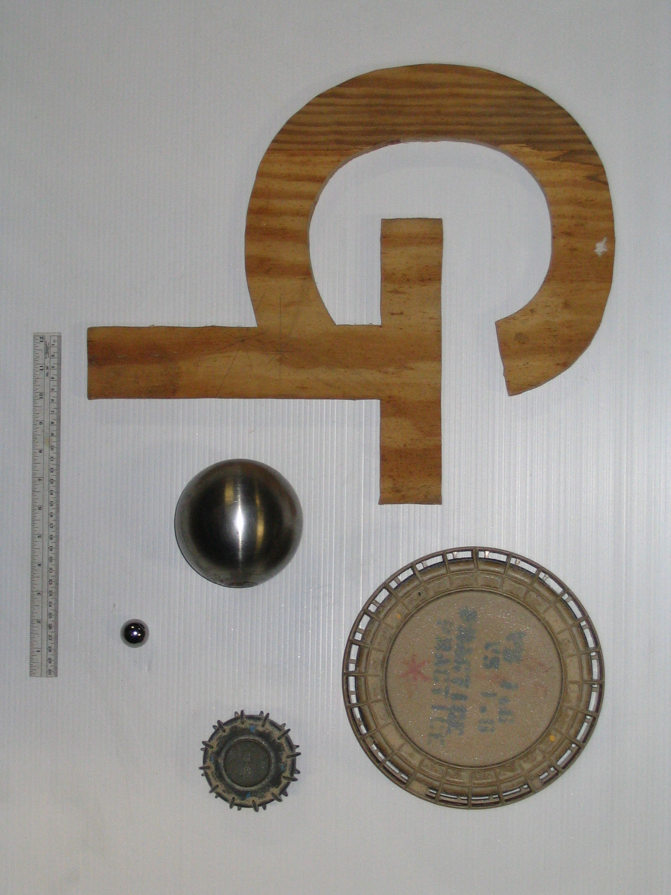
GT plywood
1” metal sphere
VS 1.6
TS-50
11cm metal sphere

Picture of air setup

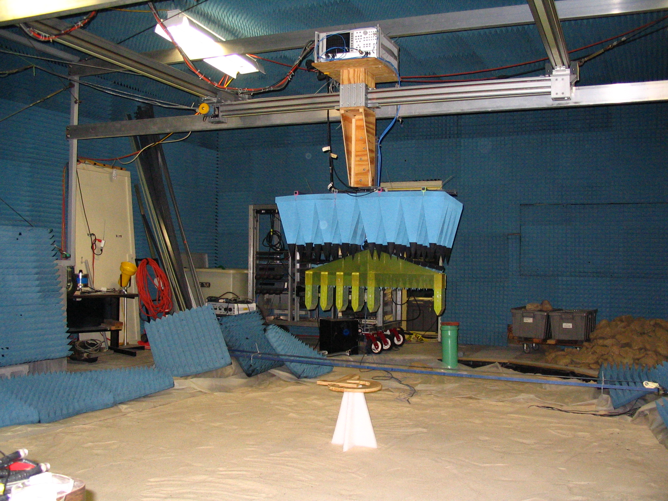
y
x

Subsurface experiment setup
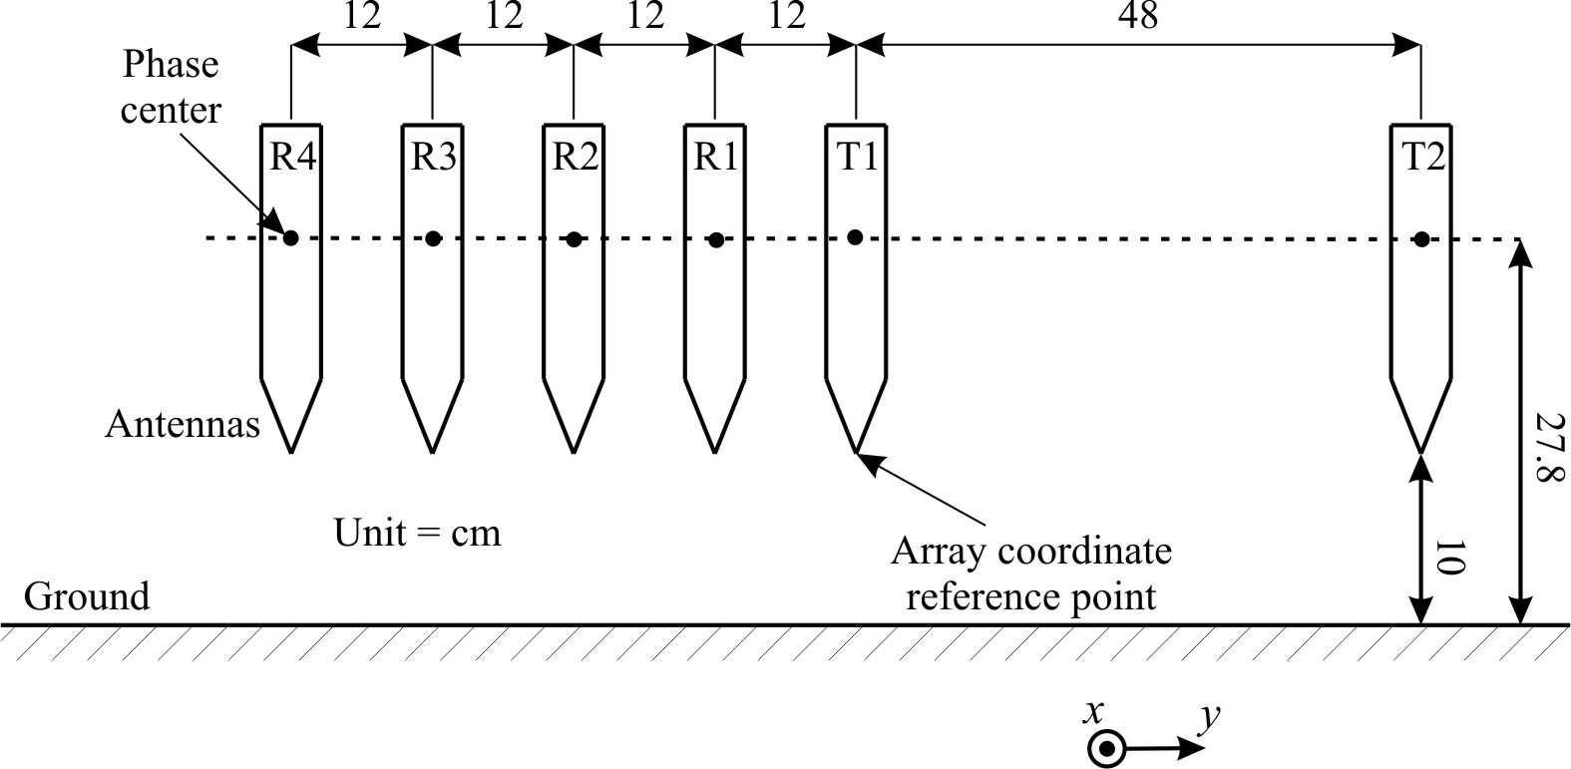

Subsurface targets
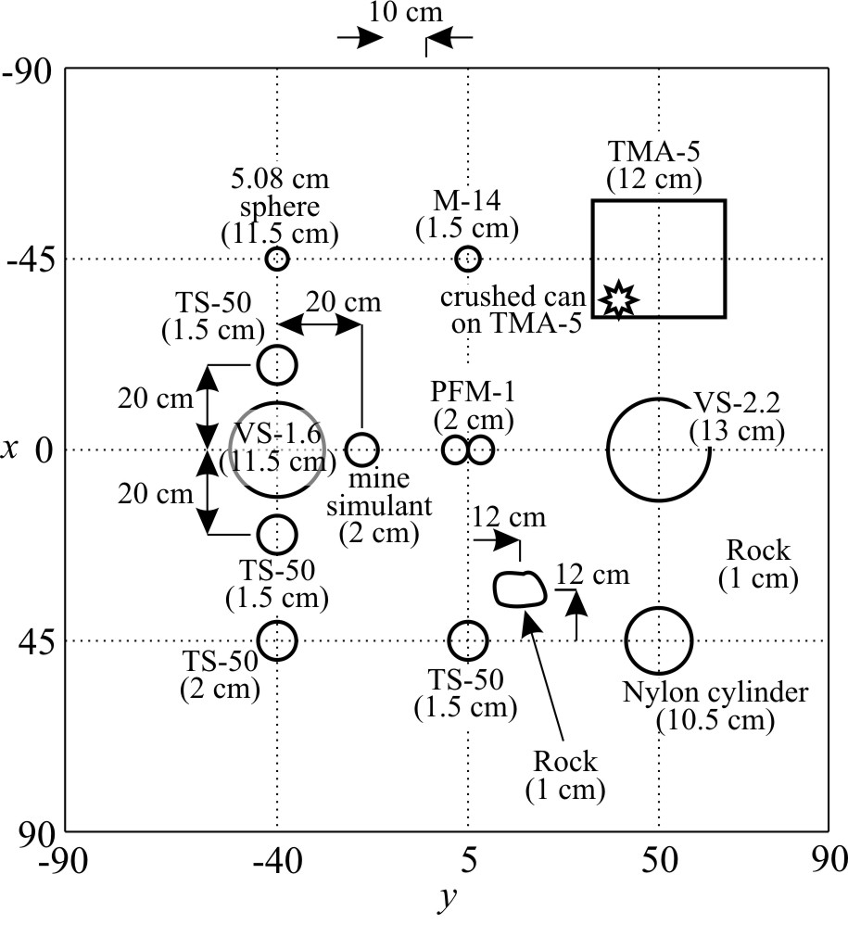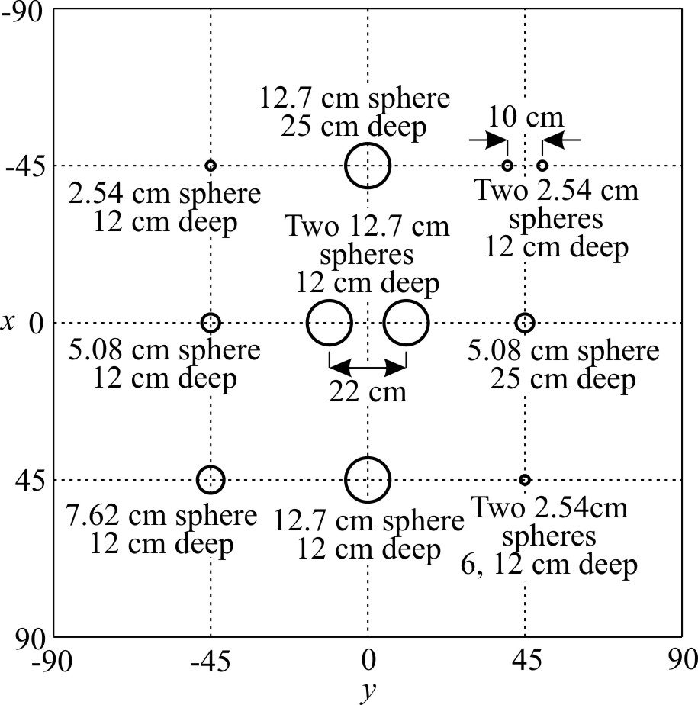
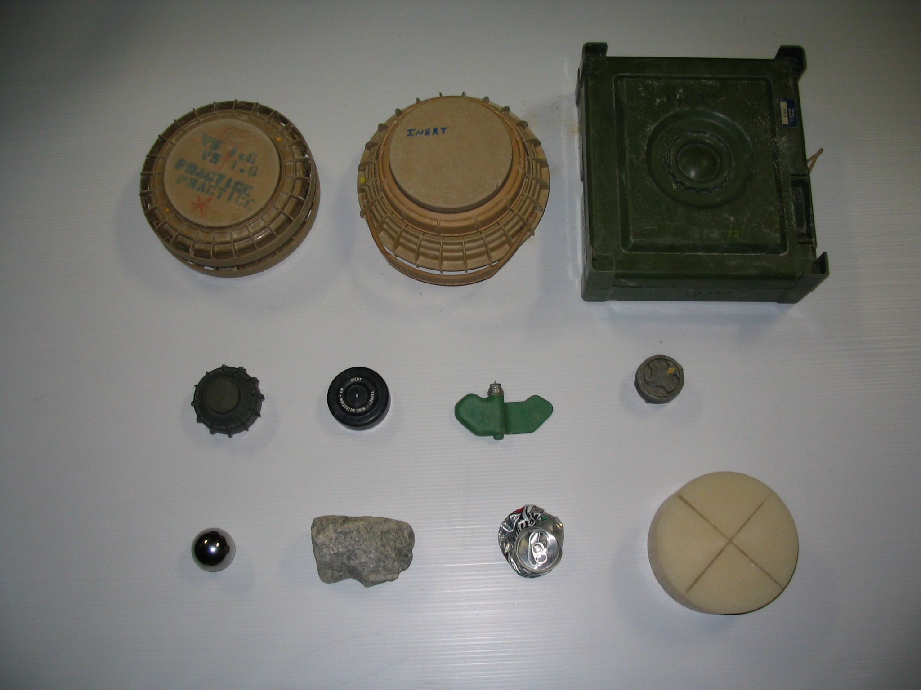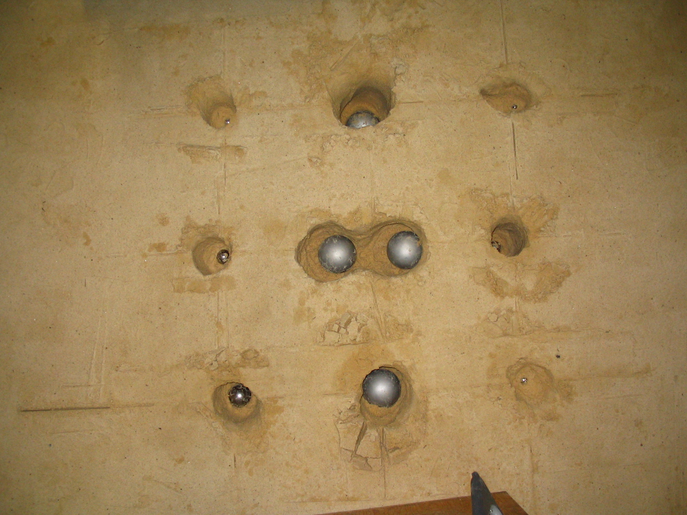

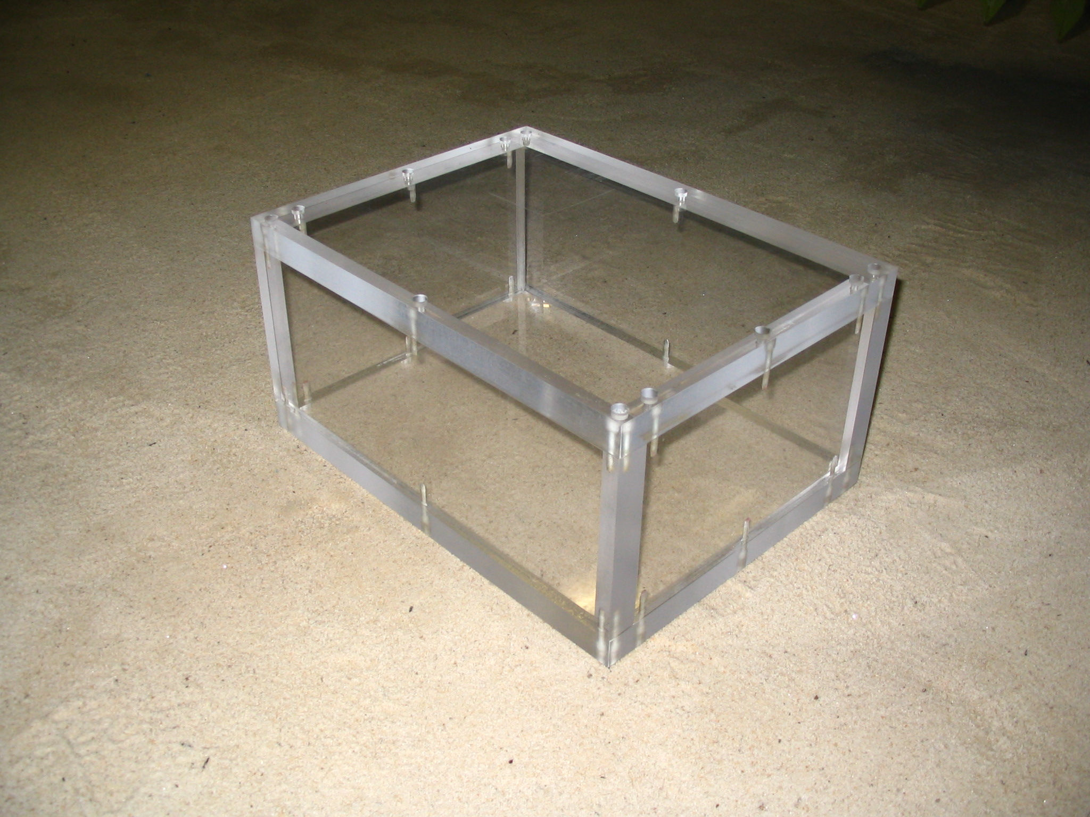

Picture of subsurface setup
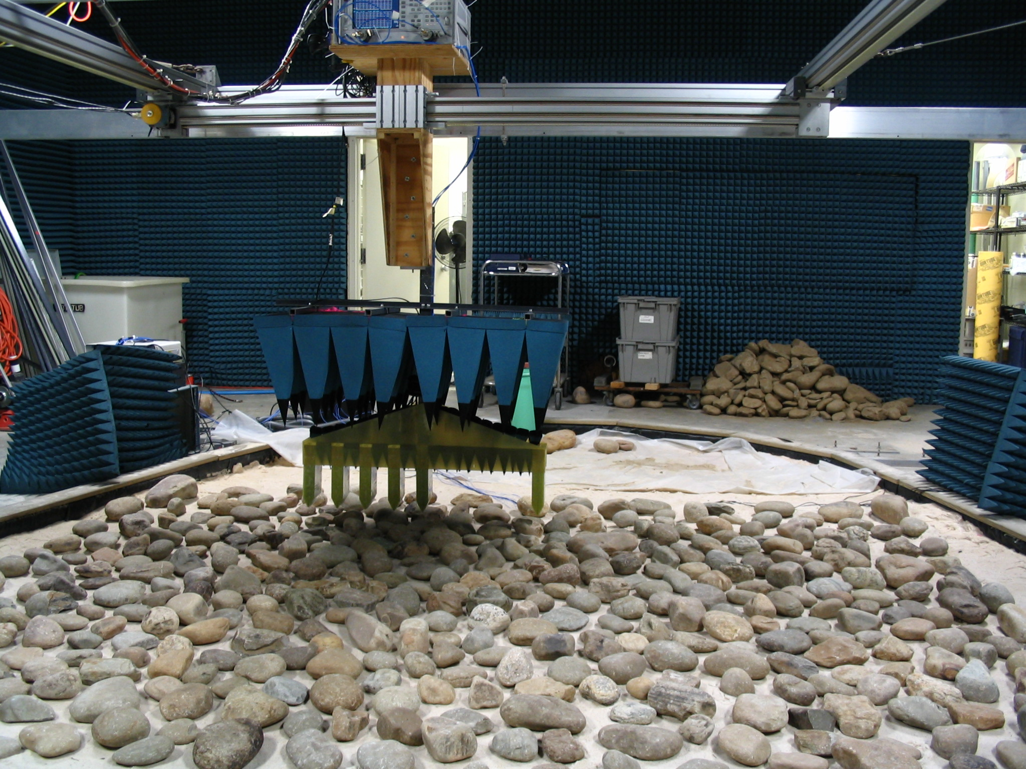

File Description:

Air targets:
air_1inSphere.mat : 1” diameter metal sphere
air_11cmSphere.mat : 11 cm diameter metal sphere
air_GT.mat : wooden GT shaped plywood sign
air_TS50 : TS-50 anti-personnel mine
air_VS16 : VS-1.6 anti-tank mine

Subsurface targets:
Nothing_clean.mat : No targets in sandbox
Nothing_rock.mat : same, except river rocks on surface
Room_clean.mat : Plexiglass box
Room_rock.mat : same, except river rocks on surface
Mine_clean.mat : Assortment of landmine targets
Mine_rock.mat : same, except river rocks on surface
Sphere_clean.mat : Assortment of metal spheres
Sphere_rock.mat : same, except river rocks on surface
Tunnel_clean.mat* : 4” diameter corrugated pipe

*The antenna was rotated 90° (such that T2 has the most extreme positive x-position) from the previous configuration.

File Contents
Each .mat file contains the following variables:
- f_meas : measured frequencies
- x,y : coordinates of measurements
- TmRn : eight matrices which contain the calibrated data. variables are indexed (freq,x,y).

