Increasing the GPU limit on the AWS
To increase the GPU limit on the AWS account please do the following: (One case per account not a case per user)
- On the top right corner of each AWS account, Go to Support -> Support Center
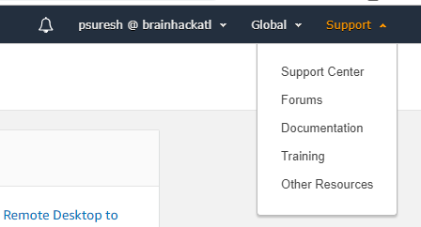
- Click on the Create Case
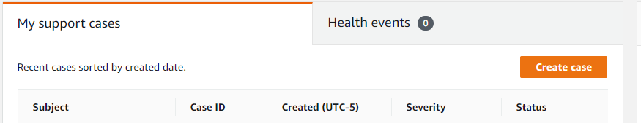

- Select Service Limit Increase
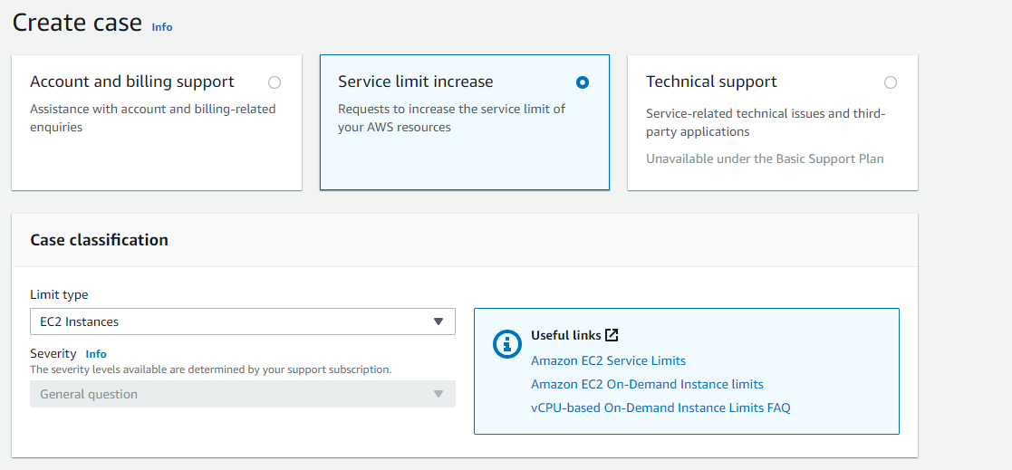
For Requests: Specify limit Value to 2 not 1
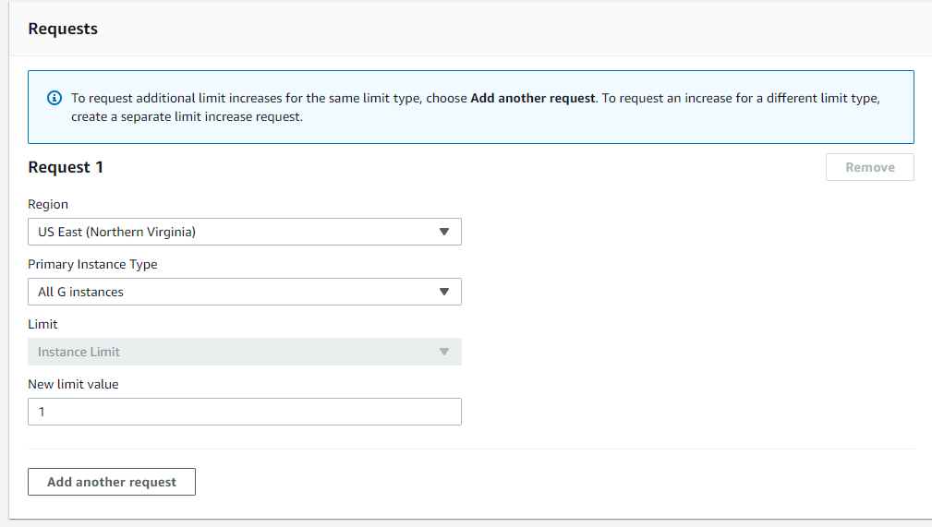
For Use case Description use this:
Please increase the g4dn.4xlarge and the g3.4xlarge instance limits to 2 (For both on-demand and the spot instance as well).
This Account will be used for hack-a-thon during Nov 13-15, sponsored by AWS Educate AWS assistance during the hack-a-thon is being provided by AWS SA Vadim Omeltchenko (vadimo@).
Thank you.

After the Case is created please send me the Case Number and team name.

