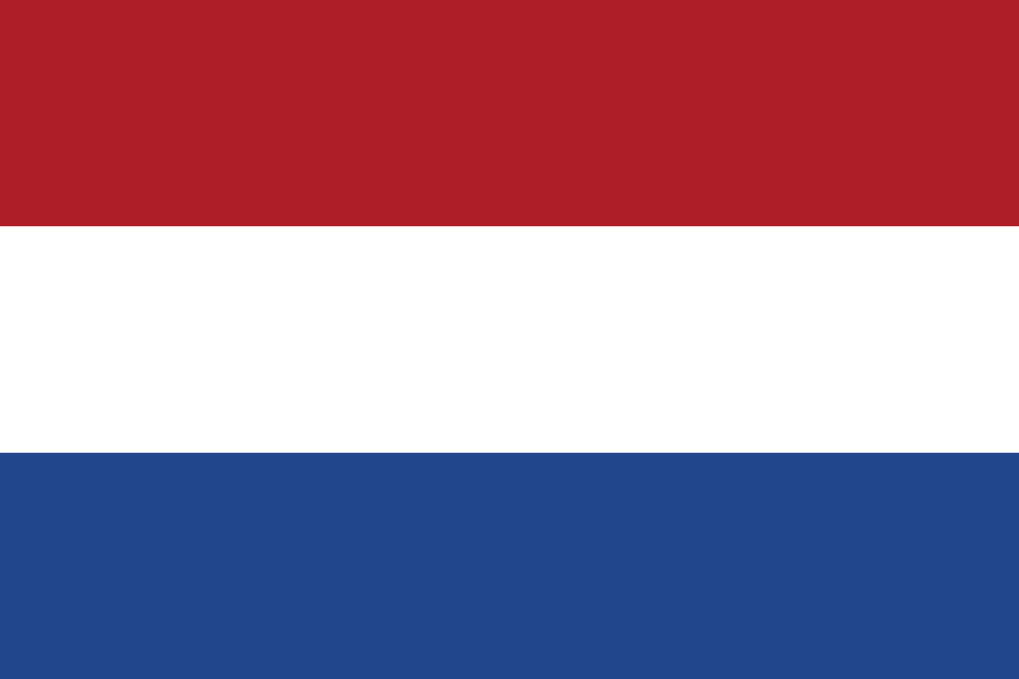
EU Study Abroad Program 2019

12 May – 21 July 2019

The European Union and Transatlantic Relations:
An Insider’s View from the Heart of Europe

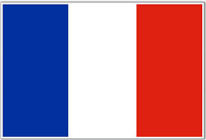
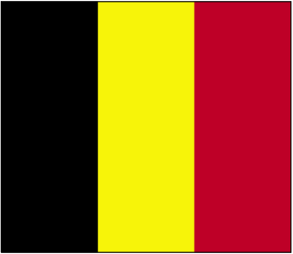
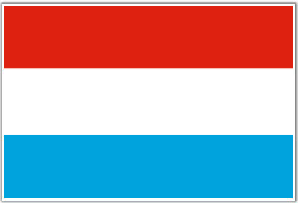

Dr. Vicki Birchfield: Program Director
EU Seminar and EU-US Relations
vicki.birchfield@inta.gatech.edu

Dr. Eliza Markley: Participating Faculty
European Security and Human Rights in Europe
eliza.markley@inta.gatech.edu

Hannah Kitzmiller: Graduate TA
hkitzmiller3@gatech.edu

This ten-week study program organized by Dr. Vicki Birchfield, Co-Director of the Center for European and Transatlantic Studies and Professor at the Sam Nunn School of International Affairs, Georgia Institute of Technology and Georgia Tech Lorraine is designed to give students an in-depth and dynamic introduction to the history of European integration, the institutions and decision making processes of the EU, current issues and debates as well as the EU’s developing role as a global actor and its relationship with the United States.

The program begins at Georgia Tech’s European campus, Georgia Tech Lorraine (GTL) in Metz, France, which is an ideal location from which to study European integration as the Lorraine region represents the very heart of French-German historical rivalry and reconciliation, cornerstones of the postwar European project. Next, students will be plunged into the institutional heart of the EU spending nearly a month in Brussels, the ‘capital’ of the EU. Here students reside with host families and engage in interactive and experiential learning visiting all of the key EU institutions as well as NATO and SHAPE headquarters, the US Mission to the EU and many other site visits to think tanks such as Bruegel and CEPS and companies like Coca Cola or UPS International Headquarters and Google Europe. Students will spend the final two weeks in the cities of Bucharest, Munich and Paris. The program is also interspersed with visits to other European cities and sites of decision-making power such as Strasbourg, Luxembourg City, and The Hague. Throughout the program, students have the unique opportunity to engage in dialogue with elected officials, policy makers, diplomats and other practitioners making the program a veritable case study of real world politics in real time!

Key issues to be examined this summer include the EU Parliamentary elections, implications of Brexit, the influence of French and German leadership in EU affairs, rising Euroscepticism and growing illiberalism in some EU Member States, debates on the future of Europe launched by Commission President Junker, the on-going migration and refugee crisis, efforts to confront radicalization and the problem of terrorism and the 70th anniversary of NATO’s founding.

*First month at GTL in Metz. The first month of the program sets the study of European integration in motion by anchoring ourselves intellectually and culturally in the region that gave birth to the three major hostilities and French-German conflicts that would in turn lead to the most politically innovative peace project and institutional mode of international cooperation and transnational policymaking seen in modern history.

*DISCLAIMER: The following schedule is subject to change given the nature of the program and the changing schedule of some of the speakers. Please check your email and GroupMe often to make sure that you are following the latest version and for important updates.

Monday, May 13  13:00-16:00  16:00- 17:00  17:00-19:00 | Meeting Point: CDG airport shuttle to Metz. Note: the bus journey will take approximately three hours.  Check –in at Residence Pythagore /Welcome greetings from Dr. Birchfield  Settle in Dorms  Group Dinner
Tuesday, May 14  09:15 - 09:45  10:00 - 14:00  14:00 – 15:30  17:00 – 19:00 | Meeting Point: Residence Pythagore  Meeting Time: 9:00 am  Breakfast  Introductions and Group trip to City Center of Metz  Trip to local grocery store  Welcome party/light dinner: GTL student lounge
Wednesday, May 15  08:30 - 09:30  09:30 - 14:00  14:00 - 16:00 | Meeting Point: Residence Pythagore  Meeting Time: 8:15 am  BREAKFAST  GTL OFFICIAL ORIENTATION + LUNCH  Introductions and LECTURE in GTL Pink Room
Thursday, May 16  08:30 - 11:30  11:30-12:30  13:30 -14:30  14:30-16:30  18:00-19:30 | Meeting Point: GTL BROWN ROOM  LECTURE: Why the EU Matters: Historical Overview and Introduction to European Integration  *Reading Assignment: McCormick Chapter 1  IN PINK ROOM: Lecture: Human Rights in Europe  IN PINK ROOM: Lecture European Security  LECTURE: Why the EU Matters cont.  GTL 2000
Friday, May 17  08:30-11:30  11:30-12:30  13:30-14:30  14:30-17:00  18:30-20:00 | Meeting Point: GTL BROWN ROOM  LECTURE: From Rome to Lisbon: Political and Economic Evolution of the EU through the Treaties  * Reading Assignment: McCormick Chapters 3 and 4  LECTURE: Human Rights in Europe  LECTURE: European Security  LECTURE: Institutions and Policy Making in the EU  GTL 2000: CESCOM Building
Saturday, May 18  09:00 - 18:00 | Meeting Point: GTL  Meeting Time: 9:00 am  Dress: Casual  Guided visits of Trier, Germany with GTL 2000  https://www.german-way.com/travel-and-tourism/germany-for-tourists/city-guides-germany/trier/
Sunday, May 19  10:00-12:00  13:00-15:00  16:00-18:00 | Meeting Point: Lobby of Residence Pythagore  Meeting Time: 9:00 am  Organized visit of Metz with guide; walking tour; visits to the Cathedral and Centre Pompidou  Visit to the see the Roman Aqueducts and the memorial site of the Dornot-Corny battle (“The D-day of Lorraine”)  Gravelotte: Museum of the Franco-Prussian War of 1870 and the Annexation  http://www.mosellepassion.fr/index.php/les-sites-moselle-passion/musee-de-la-guerre-de-1870
Monday, May 20  9:30-11:30  11:30-12:30  13:30-14:30  14:30-16:30  18:00-19:30 | Meeting Point: GTL BROWN ROOM  LECTURE: Institutions continued ….  Discussion of Brexit  * Reading Assignment: McCormick Chapters 2 and 5  LECTURE: Human Rights in Europe  LECTURE: European Security  LECTURE: TBD  GTL 2000
Tuesday, May 21  8:30-11:30  11:30-12:30  13:30-14:30  14:30-17:30 | Meeting Point: GTL BROWN ROOM  LECTURE: The Dilemmas of Widening versus Deepening: European Identity, Cultural Diversity and Citizenship in Europe  LECTURE: Human Rights in Europe  LECTURE: European Security  LECTURE: TBD
Wednesday, May 22  8:30-10:30  11:30-12:30  13:30-14:30  14:30-17:30 | Meeting Point: GTL BROWN ROOM  LECTURE: Member State Presentations  Hannah will present the founding six members + UK  LECTURE: Human Rights in Europe  LECTURE: European Security  LECTURE: Member State Presentations Continued  Reading Tonight: McCormick Ch. 9
Thursday, May 23  9:00-10:30  11:30-12:30  13:30-14:30  14:30-16:30 | Meeting Point: GTL BROWN ROOM  LECTURE: Member State Presentations Continued  LECTURE: Human Rights in Europe  LECTURE: European Security  LECTURE: EU as a Global Actor
Friday, May 24  11:30-12:30  13:30-14:30  15:30-19:30 | Meeting Point: GTL YELLOW ROOM  LECTURE: Human Rights in Europe  LECTURE: European Security  GROUP TRIP TO GRAVELOTTE  Students to be dropped off downtown afterwards  http://www.mosellepassion.fr/index.php/les-sites-moselle-passion/musee-de-la-guerre-de-1870
Saturday, May 25  07:15-18:30 | Meeting Point: GTL  Meeting Time: 7:00 am  Dress: Casual  Trip to European Parliament in Strasbourg  http://www.europarl.europa.eu/visiting/en/strasbourg/hemicycle-parlamentarium-visits  Optional Concert at Cathedral to support Notre Dame
Sunday, May 26  11:00-1:00  14:30-16:00 | Meeting Point: GTL  Meeting Time: 12:45 pm  Dress: Casual  Group Picnic in Botanical Gardens  Visit The Schuman House  http://www.centre-robert-schuman.org/robert-schuman-museum?langue=en  **European Election Day**  Optional Viewing of Vote Counts at Hotel de Ville in Metz
Monday, May 27  9:00-11:30  11:30-12:30  13:30-14:30  14:30-16:30 | Meeting Point: GTL BROWN ROOM  LECTURE: TBD  LECTURE: Human Rights in Europe  LECTURE: European Security  LECTURE: TBD
Tuesday, May 28  9:00-11:30  11:30-12:30  13:30-14:30  14:30-16:30 | Meeting Point: GTL BROWN ROOM  LECTURE: The Migration and Refugee Crisis in Europe  LECTURE: Human Rights in Europe  LECTURE: European Security  LECTURE: Review for Exam
Wednesday, May 29  9:00-11:30  11:30-12:30  13:30-14:30 | Meeting Point: GTL BROWN ROOM  LECTURE: EU SEMINAR EXAM  LECTURE: Human Rights in Europe  LECTURE: European Security  **********FOUR DAY FREE WEEKEND***********  *Free to leave after 2:30 PM and must be back for morning class on Monday  *You must notify Hannah and Dr. Birchfield of your travel plans
Sunday, June 2 | FREE WEEKEND CONT- MUST BE BACK BY 10 PM
Monday, June 3  9:00-10:30  11:30-12:30  13:30-14:30  14:30-16:30 | Meeting Location: GTL BROWN ROOM  LECTURE: Film: Europe at Sea  LECTURE: Human Rights in Europe  LECTURE: European Security  LECTURE: Group work EU/US Relations Simulation Background
Tuesday, June 4  9:00-10:30  11:30-12:30  13:30-14:30  14:30-16:30 | Meeting Location: GTL PINK ROOM  LECTURE: TBD  LECTURE: Prepare for Test  LECTURE: European Security  LECTURE: TBD
Wednesday, June 5  9:00-10:30  11:30-12:30  13:30-14:30  14:30-16:30 | Meeting Location: GTL PINK ROOM  LECTURE: TBD  LECTURE: Human Rights in Europe MIDTERM  LECTURE: European Security  LECTURE: TBD
Thursday, June 6  9:30-10:30  11:30-12:30  13:30-16:30  18:30-20:30 | Meeting Point: GTL BROWN ROOM  LECTURE: European Security MIDTERM  LECTURE: Human Rights in Europe  Leave for Verdun  Watch Testament of Youth at GTL
Friday, June 7  16:00-19:00 | Boat Tour on the Moselle and Group Picnic Dinner
Saturday, June 8  09:00 – 14:00  17:00 – 20:00 | Meeting Point: Lobby of Residence Pythagore  Meeting Time: 8:45 am  Dress: Casual  Depart Metz to The Hague  Meet in Hotel Lobby; take bus to North Sea for dinner
Sunday, June 9  09:00-17:00 | Meeting Point: Hotel Lobby  Meeting Time: 8:30 am  Group Trip to Amsterdam
Monday, June 10  13:00- 15:00  15:00 | Meeting Point: Lobby of Ibis  Meeting Time: 12:00 pm  Dress: Business Professional+ Passports  Site visit to the International Criminal Court (ICC)  Visit to the Peace Palace Museum
Tuesday, June 11  10:30  13:30-16:30  17:00 | Meeting Point: Hotel Lobby  Meeting Time: 10:00 am  Dress: Business Professional + Passports  Depart The Hague to Brussels on Bus  SHAPE Visit and Briefing  https://shape.nato.int/page1167311  Meet Host Families
Wednesday, June 12  10:00-11:00  12:00-13:30 | Meeting Point: Schuman Metro  Meeting Time: 10:00  Dress: Business Casual + Passport  Get Metro Passes  Human Rights Watch visit  https://www.hrw.org/europe/central-asia
Thursday, June 13  10:00-17:00 | Meeting Point: Schuman Metro  Meeting Time: 8:45  Dress: Business Professional + Passports  NATO Headquarters  https://www.nato.int/cps/en/natolive/topics_49284.htm
Friday, June 14  10:30-12:00  13:00-16:00 | Meeting Point:  Meeting Time: 10:00 am  Dress: Casual  Special Welcome to Ivan Allen College Dean Royster to Brussels  Panoramic Bus Tour and Walking Tour of Brussels
Saturday, June 15  16:00-19:00 | Meeting Point: Schuman Metro  Meeting Time: 9:30 am  Dress: Casual  Group Guided Visit to Royal Museum for Central Africa  **Host families invited, followed by reception  https://www.africamuseum.be/en/home
Sunday, June 16  10:00-13:00 | Meeting Point: Schuman Metro  Meeting Time: 9:15 am  Dress: Business Casual + Passports  Parlamentarium Role-playing Simulation Game  http://www.europarl.europa.eu/visiting/en/brussels/role-play-game
Monday, June 17  10:00-12:00 | Meeting Point: Schuman Metro  Meeting Time: 9:30 am  Dress: Business Professional + Passports  European Parliament Site Visit and Briefings
Tuesday, June 18  12:00-15:00 | Meeting Point: Schuman Metro  Meeting Time: 12:00  Dress: Casual  Lunch and European House of History Museum Visit  http://www.europarl.europa.eu/visiting/en/brussels/house-of-european-history
Wednesday, June 19  09:00-11:30 | Meeting Point: Exki (Rue de la Loi 232)  Meeting Time: 8:00 am  Dress: Business Professional + Passports  European Commission Site Visit  Focus: Competition Policy and EU Tech Regulation https://ec.europa.eu/commission/index_en
Thursday, June 20  10:00 - 12:30 | Meeting Point: Schuman roundabout  Meeting Time: 9:15  Dress: Business Casual + Passports  Google Europe
Friday, June 21  10:00-14:00 | Meeting Point: Schuman Metro  Meeting Time: 9:15  Dress: Casualazx  Waterloo  http://www.bbc.co.uk/timelines/zwtf34j
Saturday, June 22 | Weekend with host families  *You must notify Hannah and Dr. Birchfield of your travel plans
Sunday, June 23 | Weekend with host families
Monday, June 24  08:20 - 12:00  13:15-15:00 | Meeting Point: Schuman Starbucks  Meeting Time: 8:15 am  Dress: Business Professional + Passports  Council of the European Union  Brussels Parliament
Tuesday, June 25  09:15-13:00 | Meeting Point: Schuman Metro  Meeting Time: 9:15 am  Dress: Business Professional + Passports  European External Action Service  http://eeas.europa.eu/index_en.htm
Wednesday, June 26  11:00-15:00 | Meeting Point: Cinquantenaire Park  Meeting Time: 11:30 pm  Dress: Casual  Working Picnic  Must have chapters 1, 6, and assigned chapter read!
Thursday, June 27  07:00-10:00  15:00-17:00  17:00-19:00 | Meeting Point: Parc Cinquaintenaire Parking lot  Meeting Time: 07:00  Dress: Casual  Bus Travel to Compiegne to visit the Armistice Museum and Memorial  Tour of Palace of Versailles  Group Dinner
Friday, June 28  08:00-20:00 | Meeting Location: Hotel Lobby  Meeting Time: 7:50  Dress: Business Formal  Versailles Centennial Commemoration and Symposium
Saturday, June 29  09:00-18:00 | Meeting Location: Hotel Lobby  Meeting Time: 9:00  Dress: Casual  Travel to Normandy  Trip to American Cemetery and Omaha Beach  http://www.normandie-tourisme.fr/normandy-tourism-109-2.html  Travel to Mont St. Michel  https://www.ot-montsaintmichel.com/en/histoire.htm
Sunday, June 30 | Meeting Location: Hotel lobby  Meeting Time: 11:00 am  Dress: Casual  Leave Mont St Michel to return to Brussels  Return around 19h in time for dinner with your families
Monday, July 01 | Free Day in Brussels
Tuesday, July 02  09:00-17:00 | Meeting Location: Schuman  Meeting Time: 9:00 am  Dress: Casual  Day trip to Bruges and Ghent  Canal and walking tours
Wednesday, July 03  10:00-13:00 | Meeting Point: TBD  Meeting Time: 9:30 am  Dress: Business Casual  U.S Mission to the European Union  US Mission to the EU - Groups will be expected to have generated questions in advance of the briefing. An excellent way to research current issues is by looking over the website: http://useu.brussels.state.gov/
Thursday, July 04  19:00-22:00 | Meeting Point: TBD  Meeting Time: 6:00 pm  Dress: Casual  Happy Fourth of July Celebration and dinner with Host Families!
Friday, July 05  07:30-14:30  15:00-17:00  18:30-21:00 | Meeting Point: Schuman  Meeting Time: TBD  Dress: Casual  Depart Brussels to Bucharest  Flight RO0372  Departs 10:20, Arrives 14:00  Bucharest Tour and Arrival to Ibis  Meet in Lobby and Group Dinner  “Hanul Berarilor”
Saturday, July 06  09:00-11:30  14:00-16:00 | Meeting Point: Hotel Lobby  Meeting Time: 8:30 am  Dress: Business Casual  Parliament visit/Muzeul Satului  MNAC (Muzeul National de Arta Contemporana)
Sunday, July 07 | Free Day
Monday, July 08  10:00-12:00  13:00-15:00 | Meeting Point: Hotel Lobby  Meeting Time: 9:15 am  Dress: Business Professional + Passports  Institute for Quality of Life  Ministry of Defense
Tuesday, July 09  10:00-12:00  14:00-16:00 | Meeting Point: Hotel Lobby  Meeting Time: 9:00 am  Dress: Business Professional + Passports  Ministry of Foreign Affairs  University of Bucharest Research Institute
Wednesday, July 10  08:25-09:35  12:30  13:00-15:00  18:30-21:00 | Meeting Location: Bucharest Hotel  Meeting Time: 5:30 am  Dress: Casual + Passport  Depart Bucharest to Garmisch  TAROM Flight RO315 to Munich  Coach Bus to Garmisch  Arrive at George Marshall Center  Tour of Garmisch  Group Dinner
Thursday, July 11  09:00-12:00  12:00-13:00  13:00-15:00 | Meeting Location: George Marshall Center  Meeting Time: 8:45 am  Dress: Business Casual  Briefings on current security issues and transatlantic relations on base  Lunch  Briefings Cont.
Friday, July 12  08:30 – 12:00  12:30  14:45-19:00  19:00-21:00 | Meeting Location: George Marshall Center  Meeting Time: 8:30 am  Dress: Casual  Depart Garmisch to Munich  Visit to Dachau Concentration Camp  https://www.jewishvirtuallibrary.org/history-and-overview-of-dachau  Arrive at Hotel Ibis Munich City Center  Meet in Lobby; Third Reich Tour of Munich  Group Dinner- Hofbrauhaus  http://www.hofbraeuhaus.de/en/welcome.html
Saturday, July 13 | Free Day
Sunday, July 14  15:30-17:00  18:30-23:00 | Meeting Point: Hotel Lobby  Meeting Time: TBA  Dress: Casual  Depart Munich to Paris  AF1623, departs at 15:30  Transfer from CDG to Check in Hotel Bonaparte  Meet in Lobby for Dinner Cruise and Fireworks for Bastille Day  https://www.marina-de-paris.com/en/produit/bastille-day-dinner-cruise-unique-moment-paris/
Monday, July 15 | FREE DAY !!!!  https://en.parisinfo.com
Tuesday, July 16  08:30 -10:45  14:30-16:30 | Meeting Point: Hotel lobby  Meeting Time: 7:45  Dress: Business Business Professional +Passports  Assemblée Nationale  http://www.assemblee-nationale.fr  Tour and briefing at French Parliament + Meeting with MP Richard Lioger  Ministry of Foreign Affairs – Le Quai d’Orsay  French Ministry of Foreign Affairs: Briefing on French diplomacy and foreign policy, role of France in the EU, and tour of the Grands Salons  https://www.diplomatie.gouv.fr/en/the-ministry-and-its-network/history/
Wednesday, July 17 | Meeting Point: Hotel lobby  Meeting Time: TBD  Dress : Business Professional and Passports  US Embassy  Official visit and briefings on US-French relations with focus on commercial and economic ties and cooperation on counter-terrorism  The George C. Marshall Center  https://fr.usembassy.gov/embassy-consulates/paris/george-c-marshall-center/
Thursday, July 18 | Meeting Point: Hotel  Meeting Time: 09:00  Dress: Business Casual  IFRI http://www.ifri.org/  Briefings by Head of Security Division on French foreign policy  OECD http://www.oecd.org/about/  Briefings by former GT and Nunn School Alumni Ted Bryan and Colby Mangels
Friday, July 19 | FREE DAY !!!  Optional:  French National Museum of History of Immigration  https://en.parisinfo.com/paris-museum-monument/71293/Musee-national-de-l-histoire-de-l-immigration  Van Gogh Sound and Light Show  https://www.atelier-lumieres.com/fr/votre-visite/horaires-et-acces
Saturday, July 20  09:00 -11:30 | Meeting Point: Hotel lobby  Meeting Time : 9 :00  Dress: Business Casual  Le Sénat Français  Tour of the French Senate + Briefing from Christophe-André FRASSA  http://www.senat.fr/lng/en/index.html  Tour of Pantheon http://www.pantheonparis.com/  Farewell pastries in the Luxembourg Gardens
Sunday July 21 | Program Ends/Transfer to Airport after breakfast

Hotel Information
The Hague
(June 8-12) Ibis Den Haag City Centre
Jan Hendrikstraat 10, 2512 GL The Hague;
TEL :+31 70 318 4 318
ibis.com-accorhotels.com

Versailles
(June 27-29) Ibis Versailles Chateau
4 Avenue du Général de Gaulle
78000 Versailles, France
+33 1 39 53 03 30

Bucharest
(July 5-10) Ibis Palatul Parlamentului City Centre
82-84 Izvor Str.
Bucharest, Romania
+40 21 401 1000

Garmisch
(July 10-12) The George Marshall Center
Gernackerstraße 2
82467 Garmisch-Partenkirchen, Germany

Munich
(July 12-14) Ibis Muenchen City
Dachauer Str. 21, 80335 München, Germany
+49 89 551930

Paris
(July 14-21) Hotel Bonaparte
61 Rue Bonaparte, 75006 Paris
+33 1 43 26 97 37
http://www.hotelbonaparte.fr

Contact Information:
Director:
Dr. Vicki Birchfield: France +33 (0)7 89 88 48 13
*() denotes you drop the “0” unless you are dialing from another European landline or mobile number yourself.
(Back-up # +1 404 660 0038 ; Email: vicki.birchfield@inta.gatech.edu)

Note: When dialing from US, dial 011, country code, (e.g., 33 for France, 32 for Belgium) then number; when dialing from Europe, dial 00, then country code (e.g., 1 is for the US) and number.

Dress Code:
*Casual means you may wear whatever you wish (preferably not your gym clothes!)
*Business casual means no jeans (unless dressy/European style), shorts, or flip-flops (males: khakis and a dress shirt; females: skirt or pants and a nice blouse)
*Professional/business refers to attire you would wear for a job interview (males: suit and tie; females either a business suit or skirts and pants and a blazer or jacket)

