白瑞雪 － 文化文章

萨顶顶
- 萨顶顶是我最喜欢的中文歌手。
- My favorite of her works is “Alive – Mantra” (万物生， 梵文), which is actually performed not in Mandarin, 普通话, but in Sanskrit 梵文。
- In many of her works, she makes up words and tones to show emotion. This is particularly important in languages where many words are no longer known such as 梵文。
- She also performs a version of “Alive” in 普通话. The lyrics are particularly insightful and illuminated the difficulty of translating Mandarin poetry to English. I could recognize some phrases such as 两条鱼 but needed to look up the lyrics and translation. I do not think there exists a translation that fully shows the emotion of the Chinese lyrics.
- For example the beginning phrase “从前冬天冷呀夏天雨呀水呀” is understandable even for me as a beginner Chinese student, but the English doesn’t quite portray the emotions of the Chinese words. The Chinese words’ individual diction is as choppy and cold as a 非常冷的冬天yet together they flow as loosely as 水 and 夏天雨。
- When she belts “我看见山鹰在寂寞两条鱼上飞,” an English translation of “I saw the mountain eagle flying over two lonely fish” does not quite do the lyrics justice. Even as a beginner, I can hear the metaphor in her Chinese – I immediately connect to it as the image she describes is very human, real, and modern.

肖慕漪摄影
- 肖慕漪 (Xiàomùyī) was featured on CNN for her work on youth marriage in China.
- I decided to include it in my practicum after seeing one particularly arresting photo.
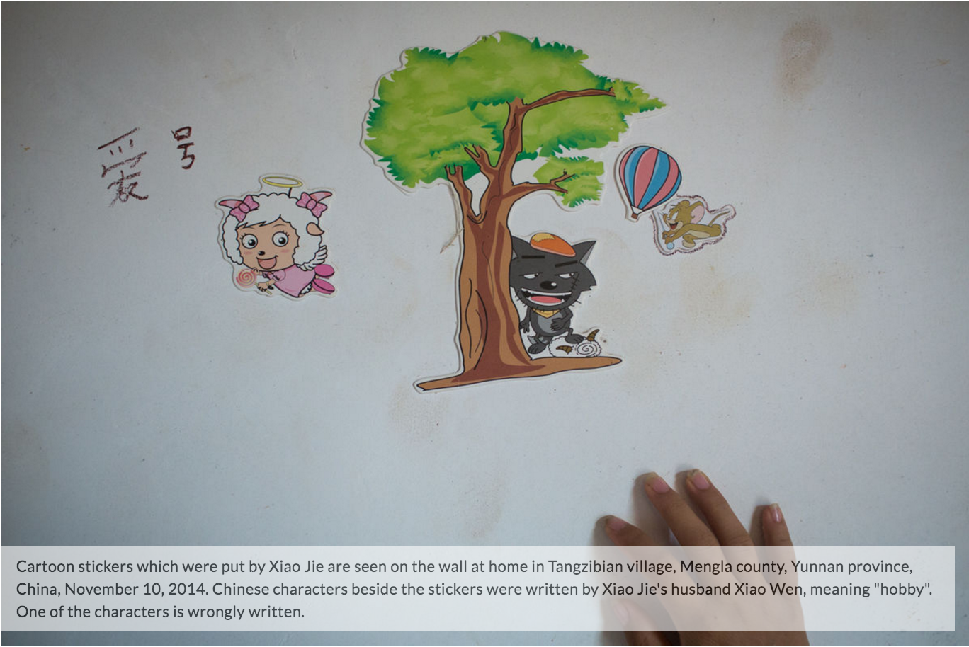
- While the description says, “one of the characters is wrongly written,” this particular character that we learned in 2002 Chinese particularly struck me. 爱好 is such a simple word that Xiao Wen’s mistake truly shows the education disparity in rural parts of China.
- While child marriage is illegal in China, it is still a frequent phenomenon in rural areas. According to the CNN article, Xiao Muyi asserts that this is due to a lack of sex education in these parts of China. It should also be noted that a severe gender discrepancy exists in China–due in part from the One Child Policy.

伯牙故事
- After learning about it in class, I became interested in this story and the meaning of 知音 .
- “伯牙琴声所弹到的地方，钟子期都能意会，而且用言语表达出来”
  - “Bó yá qín shēng suǒ dàn dào dì dìfāng, zhōng zi qī dōu néng yì huì, érqiě yòng yányǔ biǎodá chūlái”
- I thought the translations I found online and my own translations showed more of how 知音 describes a deep and beautiful friendship. Our textbook description “one who truly understands” does resonate with this, but “soul mate” isn’t as applicable to friendship.
- In the past I have volunteered to give a speech during sorority recruitment. I plan to use this as the basis for my speech this year, as I feel the friendship described in the story mimics my love for my sisters—particularly for my roommate and my “big sister.”
- I sent the story to my biological older sister. She said she also felt it was impactful and sent it to her Chinese coworker. She said he told her that the story was even more meaningful in Chinese and I hope that as my Chinese improves, this story will continue to come to life and enlighten me.

道德经
- I read A Million Little Pieces by James Frey over break and the first few weeks of school. The book follows Frey as he perseveres drug rehabilitation. Part of rehab is finding religion, and Frey describes how the Dào Dé Jīng guided him through his treatment and helped him find peace.
- There exists a lot of controversy over A Million Little Pieces. After publishing the book as a non-fiction work, Frey admitted that much of what he includes in the book is exaggeration or fabricated, and therefore it is fiction. However, after reading parts of the 道德经 I came to understand Frey’s basis for philosophy and how for him, the physical truth and his perception of his world come to form a new truth—a worldly truth, a true truth.
- The Dao (the way) describes emptiness and I can see where from this text one would find self-acceptance. After reading much of the道德经 in English I still have not come to form as deep of a relationship with it as I would like. I hope that as I enhance my Chinese skills, I will be able to understand more of the Chinese text and come to a deeper grasp of the Dao.
- Part of this book that I find striking is,“挫其锐，解其纷， 和其光， 同其尘”
  - “Cuò qí ruì, jiě qí fēn, hé qí guāng, tóng qí chén”
  - One English translation is “It blunts the sharpness, Unravels the knots, Dims the glare, Mixes the dust”
  - There are so many different English translations that I almost need to go through translating word by word translate it myself
  - 挫 cuò: to defeat, frustrate, damp, fail, bend back, lower the town, to be obstructed
  - 其 qí: its, their, it, that, they, such
  - 锐 ruí: sharp, acute, keen, rapid, fighting spirit, sudden, vigorous
- As that example shows, the poetry in this text is jarring, and the different interpretations and meanings are as vast as the Dao itself.

