VIP @ GA Tech
Student Application Process & Steps

Process | Steps | Details
Teams are entered in the system |  | - Team name  - Section number (VP1, VP2, etc.)  - Instructor
Students apply | Login
 | System pulls student info | - Name  - Email address  - Student ID  - Major  - College  - Department
 | Special options for two majors | Two majors at GA Tech allow for Senior Design, which is a three credit course. Only students form these majors see this option.
 | Student enters info | - Team preference (can choose only one)  - Year in school for semester they’ll take VIP  - Number of credits they’d like to take (1 or 2)  - Comments
 | Student clicks submit
 | Application status checked | - If the student has already submitted an application, when he/she clicks submit, the system will ask the student if he/she wants to replace their previous application with the new one.
 | Course number generated | - A course number is generated based on:  - team, which has an associated section number  - year in school, which indicates 2000, 3000 or 4000 level course  - number of credits, which is the last digit of the course number
 | Flagged as new or returning | - Applicant info is checked against past class rosters  - Application is flagged as a new applicant or returning applicant
 | Automated emails | - Email to student  - Email to approver
Application Processed | Approver logs in
 | Approver views application list | - Applications for new and returning students kept in separate lists  - clicks on names to view individual applications
 | Application approved or denied | - Application flagged as needing a permit  - Application will now appear in “waiting for permit” list.
 | Automated emails | - Email to student  - Email to person who issues permits
Permit Issued | Person who issues permit logs in
 | “Waiting for permit” table includes course number and student ID | - User does not have to click on student names to get the information he/she needs. It’s all in the table.
 | Permit issued | - Note that students who receive permits may not enroll. For this reason, the permit-issued list is not a reliable source for determining if a student is new or returning.  - An earlier version of the GT system did not check against class rolls. Instead, it had an “enrolled” button for each student, which staff would use to track enrollments.
 | Automated email | - Email to student
Semester roll-over | Two weeks after semester begins, term is rolled over to the next semester for which applications will be processed

Student Views

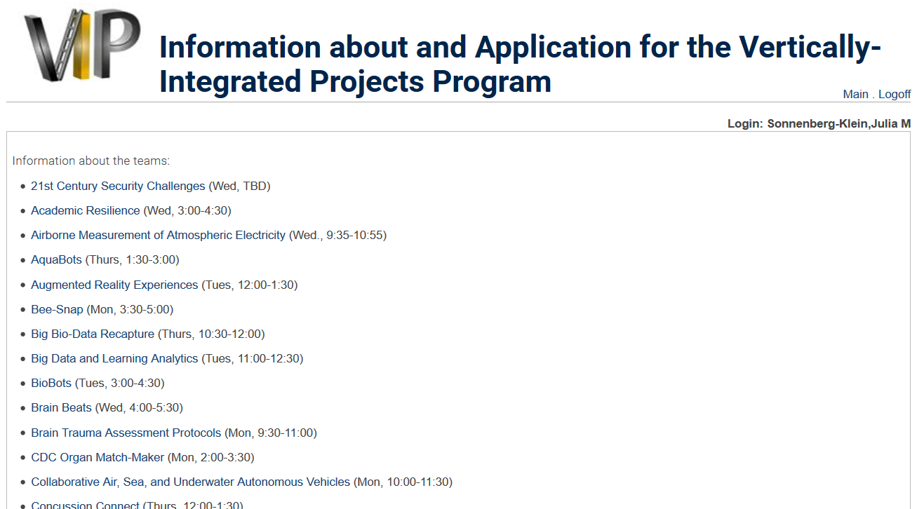
Student View and Steps:
- Students access the application via the VIP webpage.
- The top portion of our application has links back to the team descriptions. We currently include the day and time, but plan to remove this. Keeping it here and on the team info page is redundant, and it allows for mistakes (update one, but not the other, etc.).
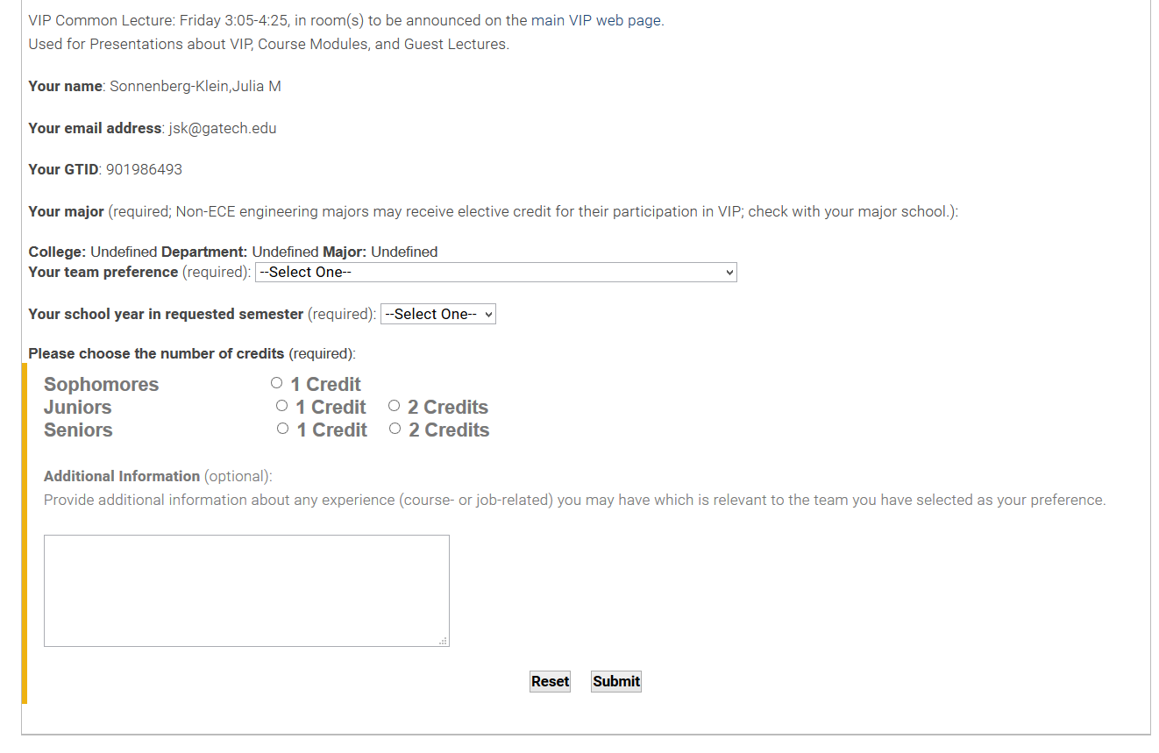
- The bottom portion of the application page shows the information the system pulled from our Student Information System:
  - Name
  - Email
  - Student ID
  - Major, College, Dept
- Students enter:
  - Team
  - Year in school that they’ll be when they enroll in VIP
  - Number of credits
  - Comments

Admin View

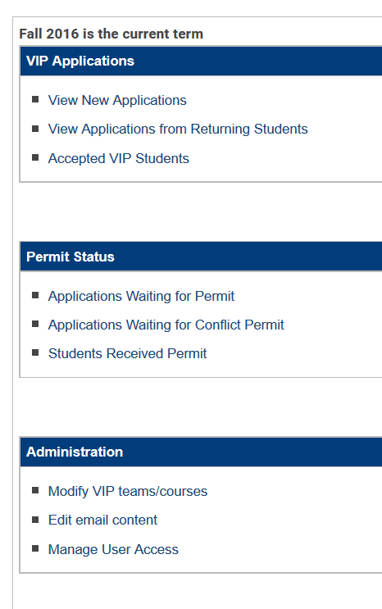

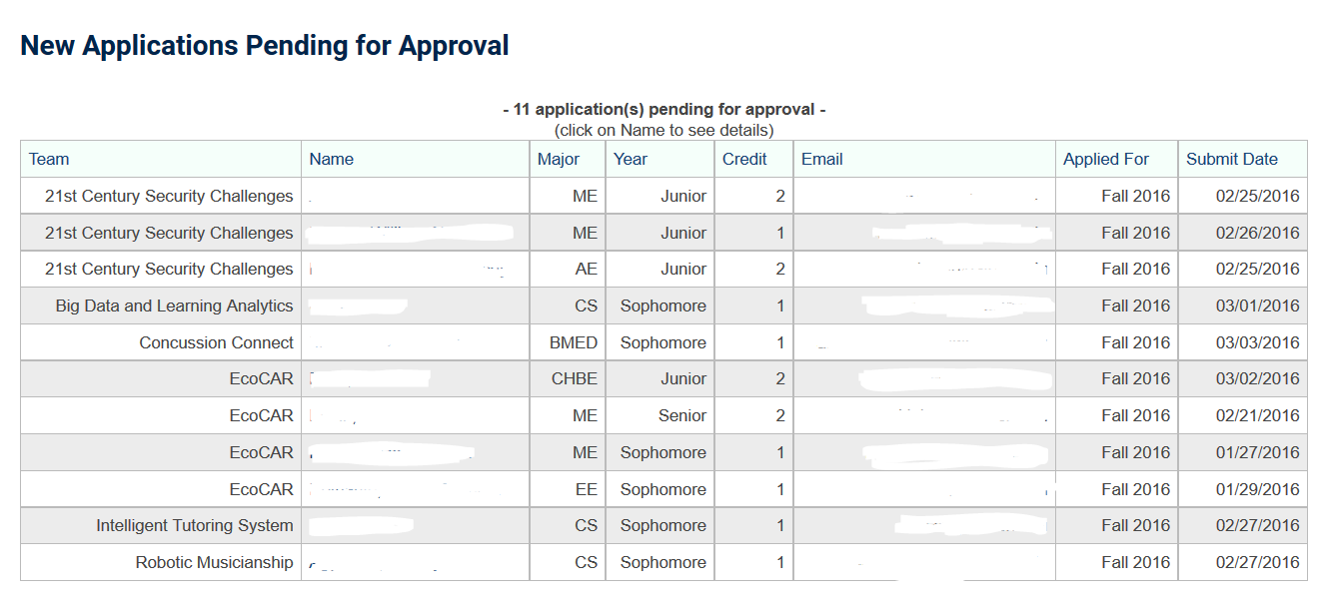

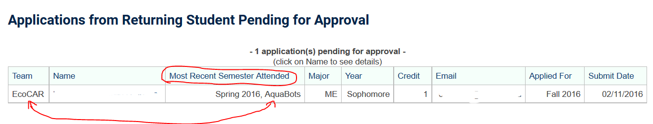
In the screenshot above, the student has applied to a different team than he/she is on this semester.
