Instructions: SharePoint Wiki setup for VIP Teams

Create SharePoint site from Teams
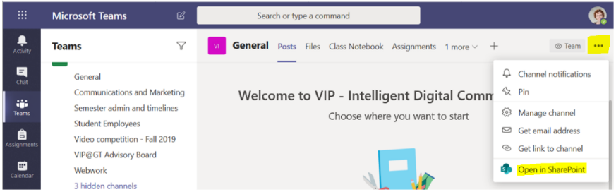
- Created a “Team” for the VIP Team in Microsoft Teams:
- To create the SharePoint Page for the Team, click the thee dots in the upper right corner and choose “open in sharepoint”
Create a Wiki Page, and set it as the Home page
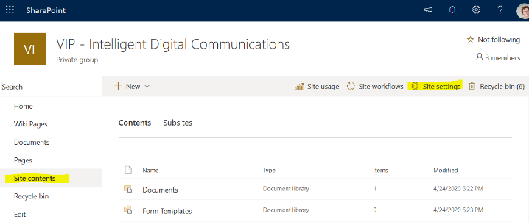
- Click on “site contents” in the left menu.
- Click on “site settings” in the top menu.
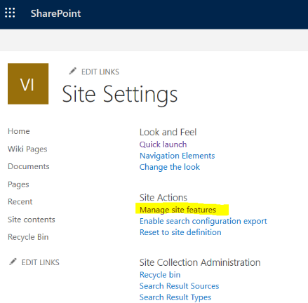
- Click on Manage site features in main section of page (under Site Actions)

4. Scroll down to “Wiki Page Home Page” and click “Activate

5. Click on “Home” in the left menu, and you’ll see that you have a new homepage, which is more of a wiki control panel.
Rework links in the left menu.
- Click “Edit Links” below the left menu.
Change | Why
Delete “Pages” link | The “Pages” page does not list wiki pages, which will be confusing. This is because Pages are a different content category, intended for news feeds and not static or user-managed content.
Delete “Site Contents” link | Again, this feature is not strongly tied to the wiki and will just cause confusion.
Rename “Home” to:  “Wiki Control Panel” | This page is actually a “page” and not part of the wiki. From here, instructors can invite users, so we’d like to keep it handy.
Move “Wiki Control Panel” to the slot above “recycle bin” | Students won’t need this link, so we want to keep it out of the way.

Add the Wiki Library (another new home page)
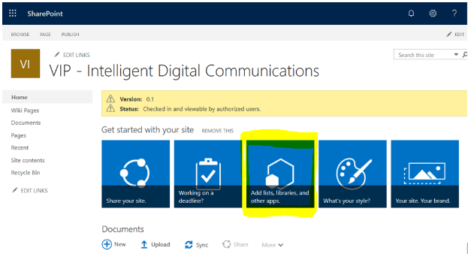
- In the Wiki Control Panel we created in the previous steps, click on the button in the main section that says “add lists, libraries and other apps.”
- The next screen will have a search box at the top. Type the word “wiki” into the box and search.
- Click on the button “Wiki Page Library.”
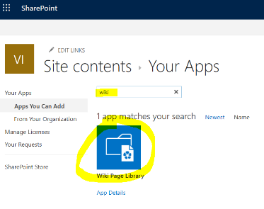
- Name the new Wiki Library “Home”

Add VIP Logo
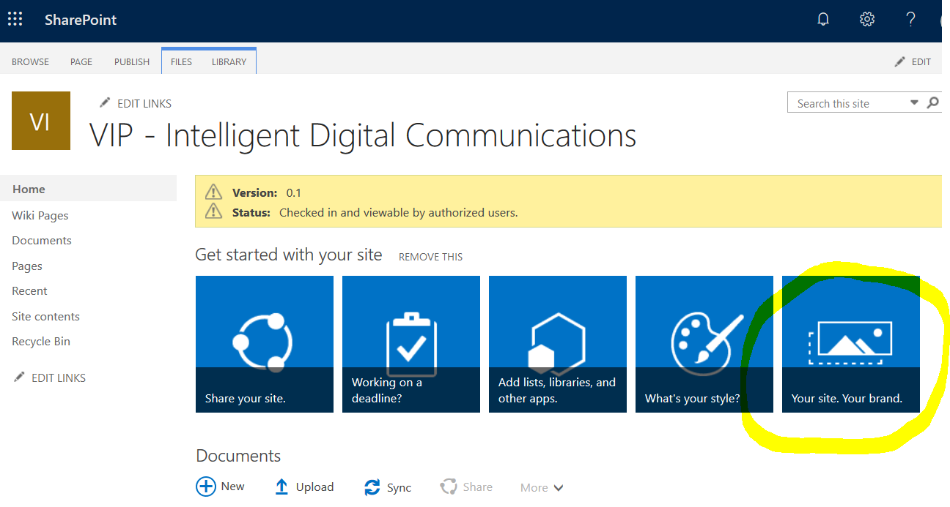
Rename “How to Use This Library”
- Click on “Home.” You will see wiki pages are listed in the upper left.
- Click on “How to Use This Library” in the upper left.
- Now we’ll edit this page in order to rename it. Click on “edit” in the upper right.
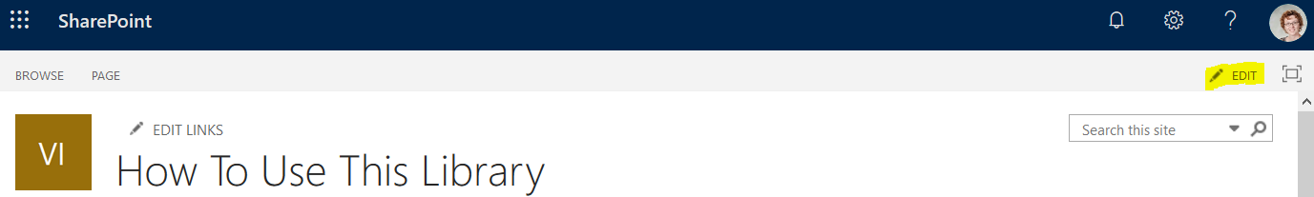
- Click on the “page” tab in the upper menu.
- Click on “rename page” below the upper menu
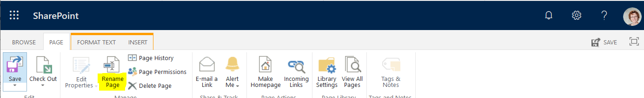
- Change the page name to “Wiki how-to” and save.

Replace text on the home page
The new home page says “welcome to your wiki library.” We want to make it clear to instructors that this is their team’s wiki page, and that they should start editing it here.

Delete the text that’s on the page, and replace it with the text below.
The first line is formatted as “heading.” The rest is formatted as “body.”

VIP Instructors, welcome to your VIP team wiki!

This will be the home page for your wiki, so please start editing here.
- To edit this page, click Edit in the upper right corner.
- To add a page:
  - Go into Edit mode.
  - Type two square brackets [[
followed by the name for your new page
followed by two more closing square brackets ]]
  - Save the page. This will create a link.
  - When you click on the new link, the system will create the new page.
Add Wiki page list to the Wiki Control Panel
In the Wiki Control Panel we created, we’d like to show a list of the wiki pages above the “documents” block.

- Click on “Wiki Control Panel” in the left menu.
- Click on “edit” in the upper right.
- Click on the “insert” tab in the upper menu.
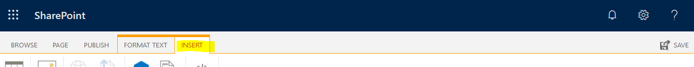
- Click on “web part” in the ribbon just below the upper menu.
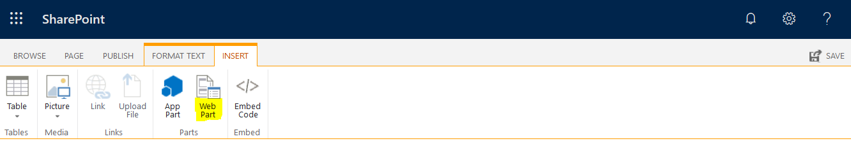
- Scroll down a little, and click in the “get started with your site” block without hitting any buttons. The border around the block will turn blue. This will put the focus here, and insert our new block immediately below this one.
- Click on “wiki pages” in the box labeled “parts,” and then click “add.” The “add” button doesn’t look like it’s active, but it is.
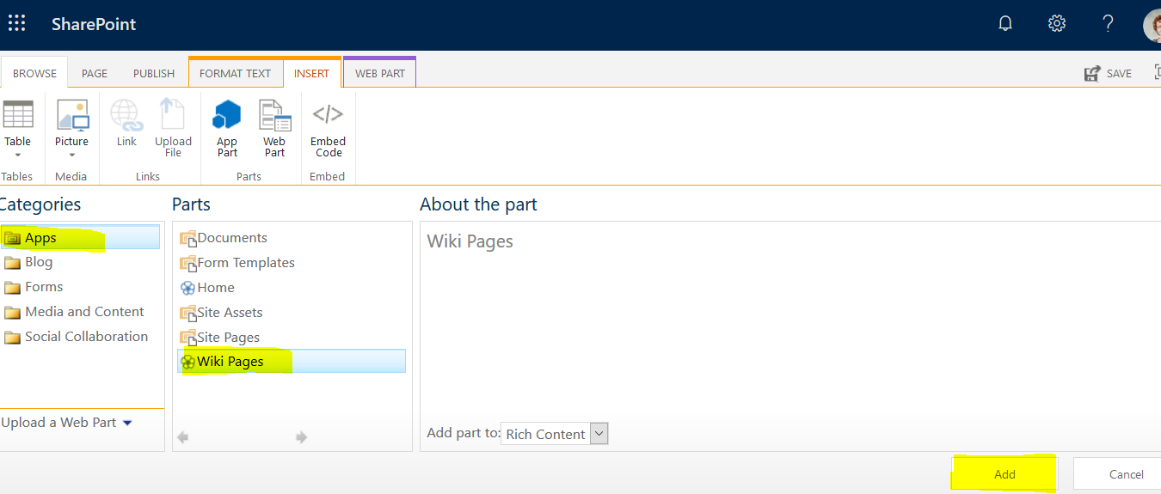
- Click Save in the upper right
