Welcome
 | By the end of the session. . .  - Outline a typical semester in VIP  - Understand the ways student roles change between semesters  - Prompts and assignments  - Find answers | 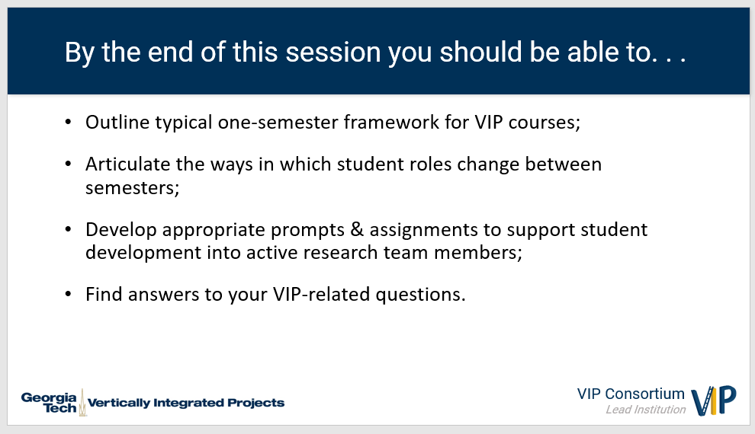
 | Introductions:  - Name  - Dept  - Experience leading teams  - 2-3 sentences about project | 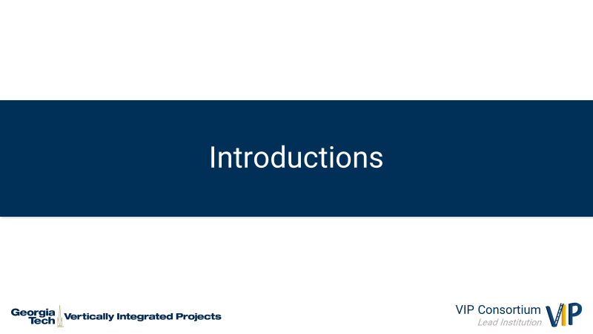
Typical Semester
 | The semester can be divided into three parts.
Middle, this is a marking-point in the semester
Let students know how they’re doing with midterm feedback

Give constructive feedback
- Note strengths
- Suggestions for improvement
- “If keep doing what you’re doing, you’d get a B. If you want to improve. . .”
Some teams re-organize:
merge or adjust their subteams

To add to handout:
Final presentations, posters or write-ups

Same process as midterm grades

To prepare for next semester, have students develop on-boarding resources
- Tutorials
- Exercises
- Clean-up common documentation

Student Roles
 | In any semester, students can be divided into  four distinct groups:  - Newcomers  - Contributors  - Leaders  - Gurus  If you look at handout page 2: how we expect students to progress over time.  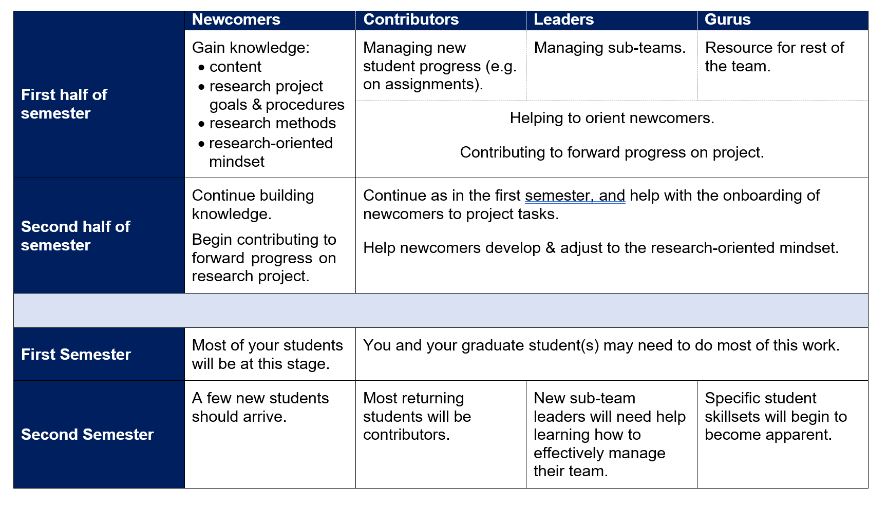  Focus on the top half of the table  - Newcomers, Contributors, Leaders & Gurus  - Newcomers  - 1st row 1st half of semester  - 2nd row 2nd half  - Next semester you’ll have returning students  - Contributors, Leaders & Gurus  - All help orient newcomers  - All contribute  - Lead as appropriate  - Contributors help new students  - Gurus serve as resources  - Leaders manage subteams  Look at bottom half  - Most teams start out with all new students,  so leadership falls to instructor and grad students  - Be sure to cultivate leadership toward end of semester (tutorials, etc.)  - Second semester, should have new and returning students  - New leaders will need help  - Good team size: 10-20  - Ensures you have returning students  - Different majors return at different rates,  depends on department credit-use policies |  | Handout: Page 2  Student Roles on VIP Research Teams  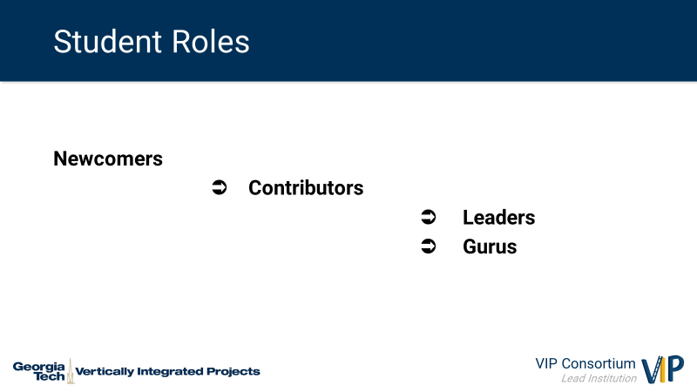
 | Now we want to think about how we move the students forward.  On handout page 3 we have two items to work through.  First we want to brainstorm.  In the first 4-8 weeks, what  specific knowledge & skills will students need to gain?  Then after you brainstorm  we want to formulate learning objectives.  What will your student need to be able to do?  Let’s get into pairs or groups  Take a few minutes to write  And then share with your partner  5-7 min Optional Share |  | Handout: Page 3  Skills and Knowledge for your Students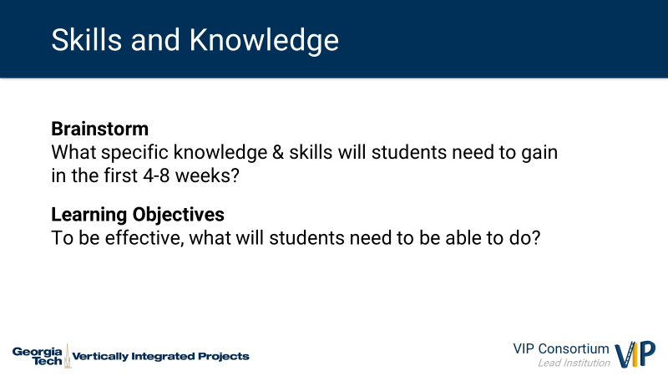
Starting Your Semester
 | Key aspects of leading a VIP Team:  First thing is the kickoff meeting  Page 4 – kickoff meeting checklist  Establishing a team dynamic  - What are some things you can do to help with this?  - Team dinner  - Shared experience?  Teaching a “research” way of thinking  - BME students will be comfortable with the VIP format  - Other students need to learn how to  - Pursue solutions on their own  - Reflect and learn from failures  - Realize you don’t have an answer key  Have an activity for you.  Page 5 – Want to design a challenge you can give your students within the first few weeks.  - Do on own.  - Would anyone like to share?  Training and supporting student progress  - Hold students accountable (can be awkward)  - Help students develop  Have a resource that CTL developed for working with graduate students: Individual development plans, Pages 6 & 7  Modified it to fit VIP.  - Could use with returning students.  - Student assesses self, identifies areas for progress  - Instructor reviews, identify resources that could help  - Meet  - Student writes/revises goals  - Instructor gives feedback  - Mid-semester check-in | Handout: Page 4  Kickoff Meeting Checklist  Page 5 Building my Team  Pages 6 & 7  Individual Development Plans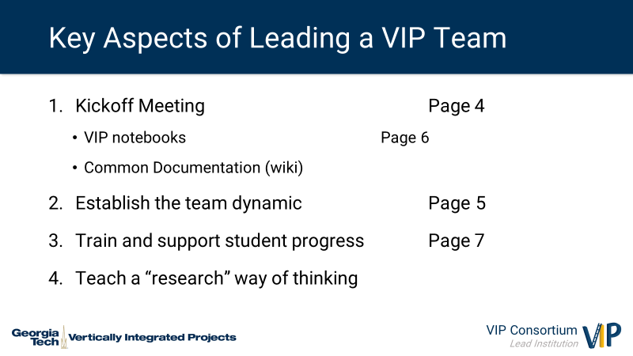

Resources for your semester

- Syllabus with dates
- Grading tools
- Student applications
  - You can view them even if you’re not the approver yet
  - Can see how many students have been approved, what majors

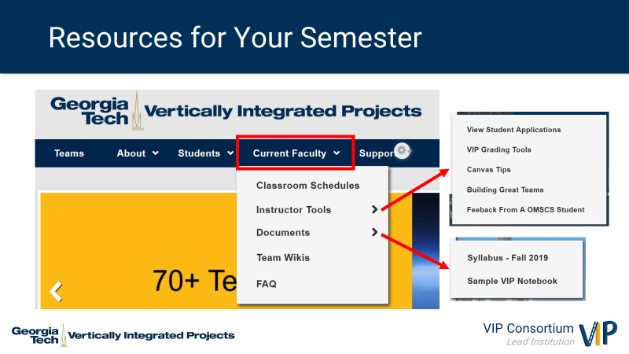
 | Items to figure out  Students take VIP for different amounts of credit.  Solutions from other teams:  - Expect more progress from 2-credit students  (could make table tent name cards w/ year and credit hours – will help other students too)  - Have 2-credit hour students serve on two different subteams (works well with teams w/ research subteams)  - Have 2-credit hour students serve as documentation masters, keeping their subteam wiki up to date and in order. | 